Prometheus and Grafana in Docker on Ubuntu 18.04LTS

24th March 2020

This Application installation and brief usage note is to supplement page 231, Chapter 9 of book: Building RESTful Web Services with Go … so that the reader can see the results of the instrumentation application ‘encryptServiceWithInstrumentation’ in Prometheus and Grafana without fully installing these programs.
These programs will be run up as individual docker containers.

1. Installing Docker:

sudo apt install docker.io

sudo usermod -aG docker ${USER}

reboot, to get group membership re-evaluated.
Then, to test, in terminal:
docker run hello-world

(the version of docker at the time of this instal is 19.03.6)

Useful docker commands:

docker ps -a

docker container rm <id> => remove container

To remove stopped containers, networks, dangling images & dangling build cache:
docker system prune

To see what images you have:
docker images

To see unused volumes:
docker volume ls -qf dangling=true

And to remove these dangling volumes:
docker volume rm $(docker volume ls -qf dangling=true)

To stop container:
docker stop <container name> (where ‘container name’ is from the last column output from ‘docker container ls -a’).

2. Setting up Prometheus for Docker:

Get the docker container for prometheus:

docker pull prom/prometheus

sudo useradd -rs /bin/false prometheus

Making folders to be mapped into prometheus Docker image for data persistance:
sudo mkdir /etc/prometheus

cd /etc/prometheus/ && sudo touch prometheus.yml

sudo mkdir -p /data/prometheus

sudo chown prometheus:prometheus /data/prometheus /etc/prometheus/*

sudo gedit /etc/prometheus/prometheus.yml

And Add:

# A scrape configuration scraping Chapter 9 example and the Prometheus server
# itself.
scrape_configs:
# Scrape Prometheus itself every 10 seconds.
- job_name: 'prometheus'
scrape_interval: 10s
static_configs:
- targets: ['localhost:9090']
- job_name: 'chapter9'
scrape_interval: 10s
static_configs:
- targets: ['localhost:8080']

NOTE: each indent above is TWO spaces for /yml file !

Check that nothing is running on prometheus port:
sudo netstat -tulpn | grep 9090

Find Prometheus User ID:
cat /etc/passwd | grep prometheus
gives:
prometheus:x:998:998::/home/prometheus:/bin/false

From the above line, use whatever numbers you get for 998 in the line below as highlighted.
To start Prometheus on Docker (all one line, cut & paste into terminal):

docker run -d -p 9090:9090 --user 998:998 --net=host -v /etc/prometheus/prometheus.yml:/etc/prometheus/prometheus.yml -v /data/prometheus:/data/prometheus prom/prometheus --config.file="/etc/prometheus/prometheus.yml" --storage.tsdb.path="/data/prometheus"

Explanation:
docker run -d -p 9090:9090 --user 998:998 --net=host
-v /etc/prometheus/prometheus.yml:/etc/prometheus/prometheus.yml
-v /data/prometheus:/data/prometheus prom/prometheus
--config.file="/etc/prometheus/prometheus.yml"
--storage.tsdb.path="/data/prometheus"

The ‘-v’ parameters allow the host path to be accessed from within Docker and have the following order:
-v /path/on/host:/path/in/container

The “/path/in/container” is created in the container and populated with what is in “/path/on/host”. The container will then update files in “path/in/container” and in “path/on/host”.

--storage.tsdb.path is Prometheus Base path for metrics storage. Colour highlight used to show where it matches the -v command.

--config.file Prometheus configuration file path. Colour highlight used to show where it matches the -v command.

(at time of writing the above ran version 2.16.0 of Prometheus)

Check that the above is ‘Up’ under STATUS, do:
docker container ls -a

And if it is not, try the ‘docker run ...’ line above again but without the ‘-d’ flag to see some feedback as to what the error is and do some google searching.

-=-=-

And to check, enter URL in browser: localhost:9090/metrics

Run the program ‘encryptServiceWithInstrumentation’ from Chapter 9 of Building RESTful Web Services with Go and follow the instructions on page 230
Then, in browser enter URL: localhost:9090 and select Graph to get:
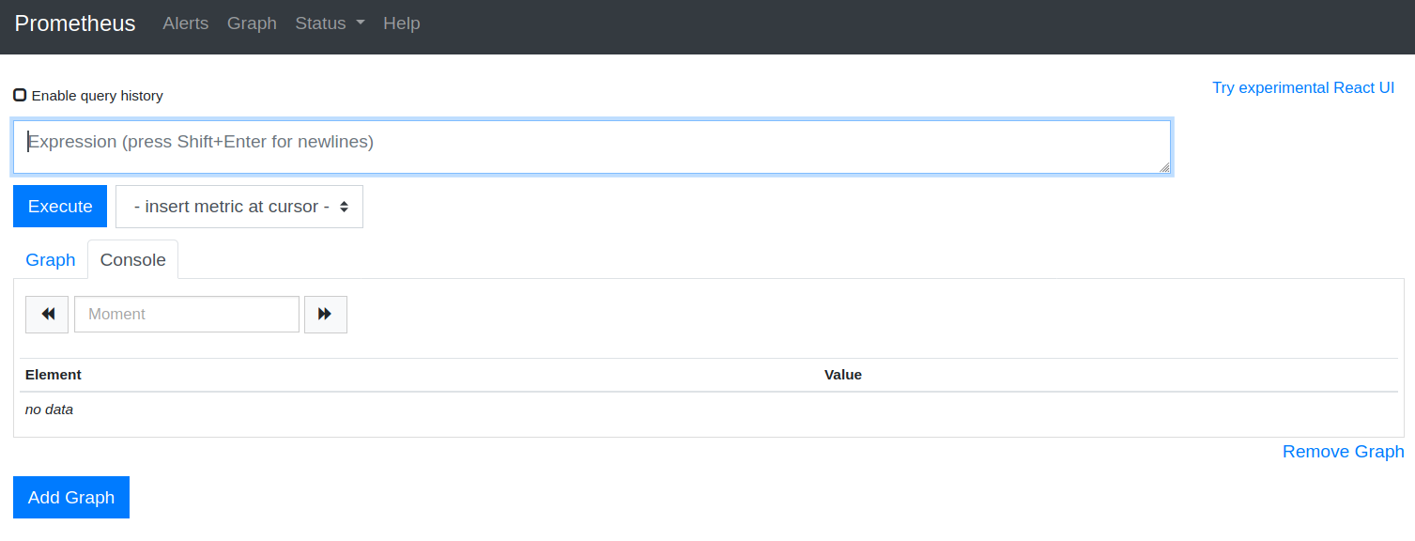
Then select Status/Targets to see:
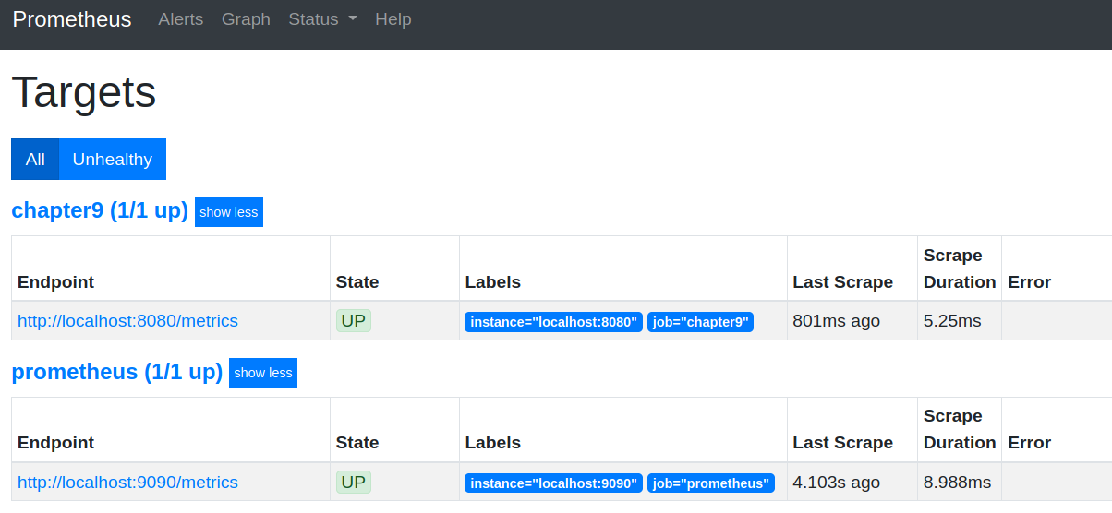
Click on “http::localhost:8080/metrics” to get a lot of info (just showing first 4 lines here):
# HELP encryption_my_service_request_count Number of requests received.
# TYPE encryption_my_service_request_count counter
encryption_my_service_request_count{error="false",method="decrypt"} 11
encryption_my_service_request_count{error="false",method="encrypt"} 6
# HELP encryption_my_service_request_latency_microseconds Total duration of requests in microseconds.

Copy “encryption_my_service_request_count”
and press back on browser.

Click on Graph and paste what was just copied into the Expression box and press Enter a few times. Click on Execute and select the Graph TAB below EXECUTE to get something like:
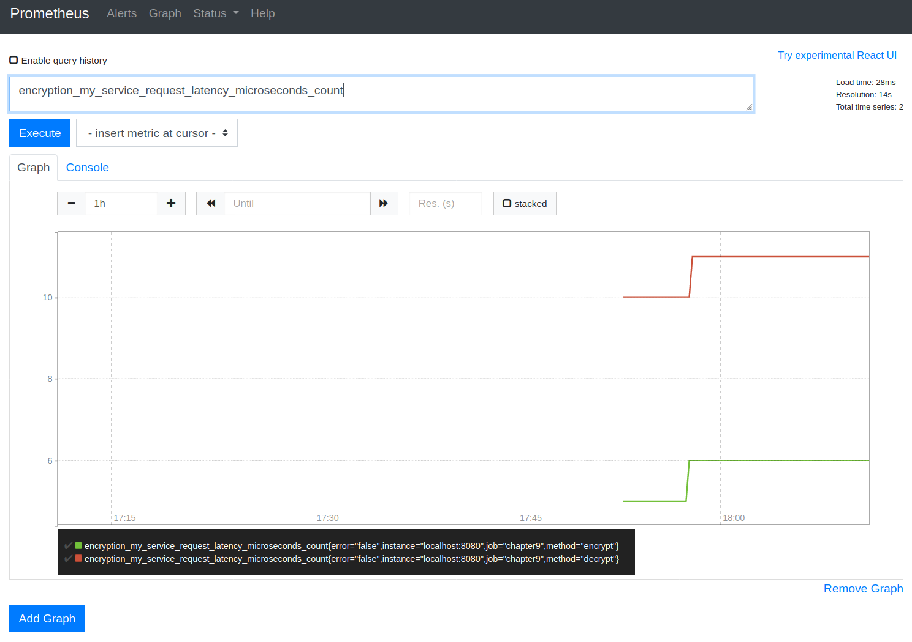

-=-=-
25th March 2020

3. Get Prometheus metrics into Grafana

Doing the following will download (if not already downloaded) and launch Grafana:
docker run -d -p 3000:3000 grafana/grafana

(at time of writing, this runs up version 6.7.1 of grafana)

Connect to it in browser at URL localhost:3000
to get:
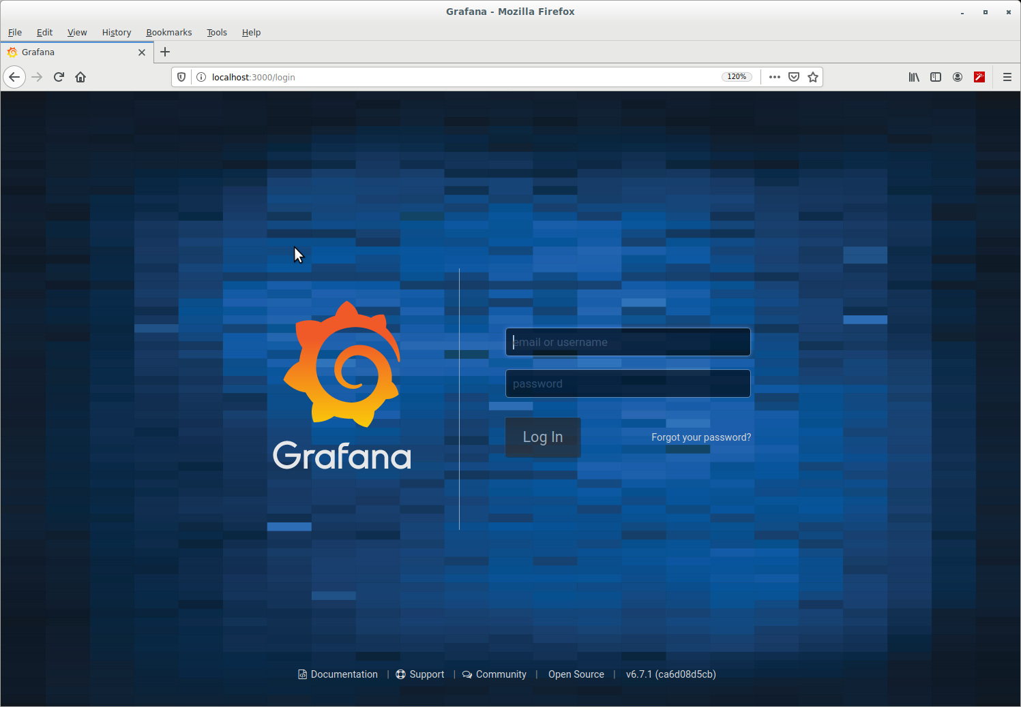

Then simply login as user:admin password:admin
and for now select skip,
to get the home page:
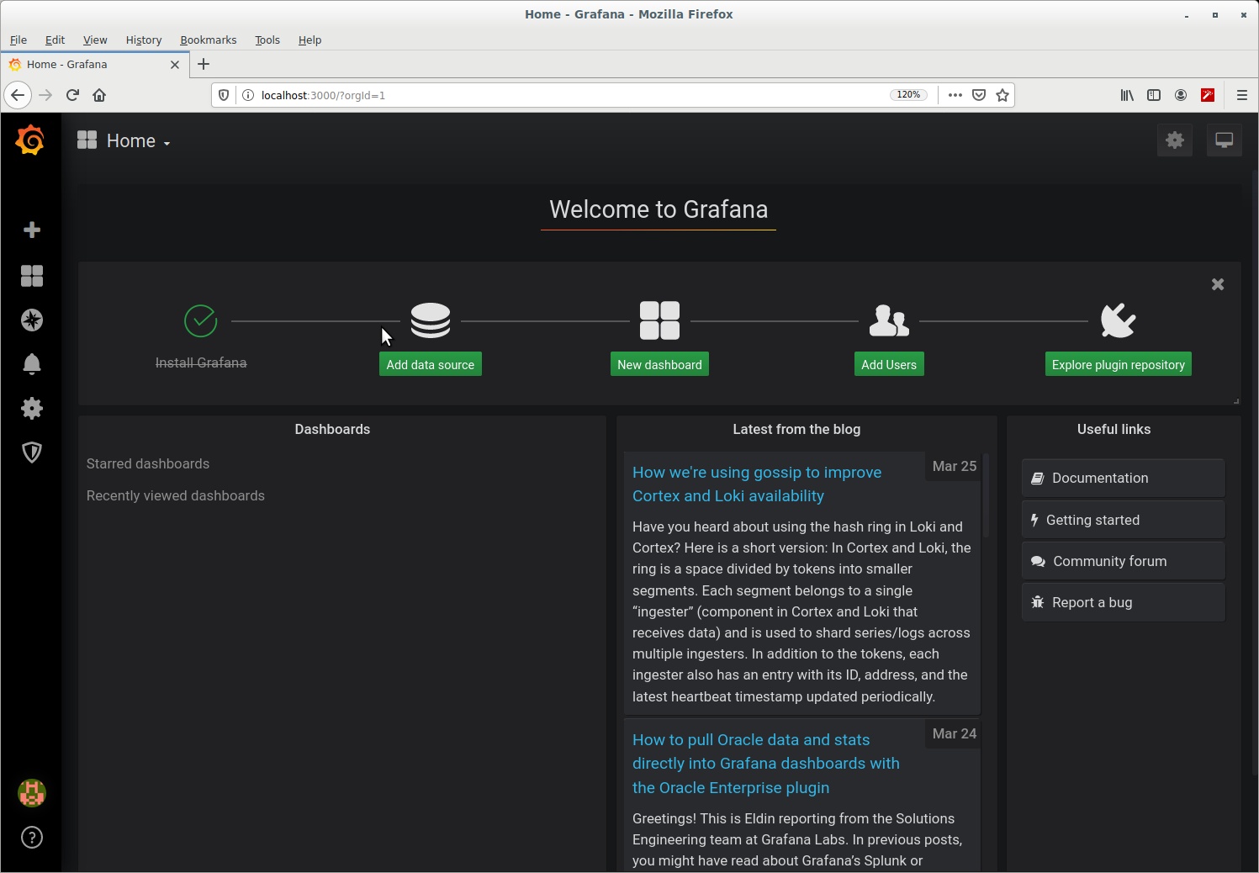
Click on Add Data Source and then hover mouse over Prometheus and click to select …
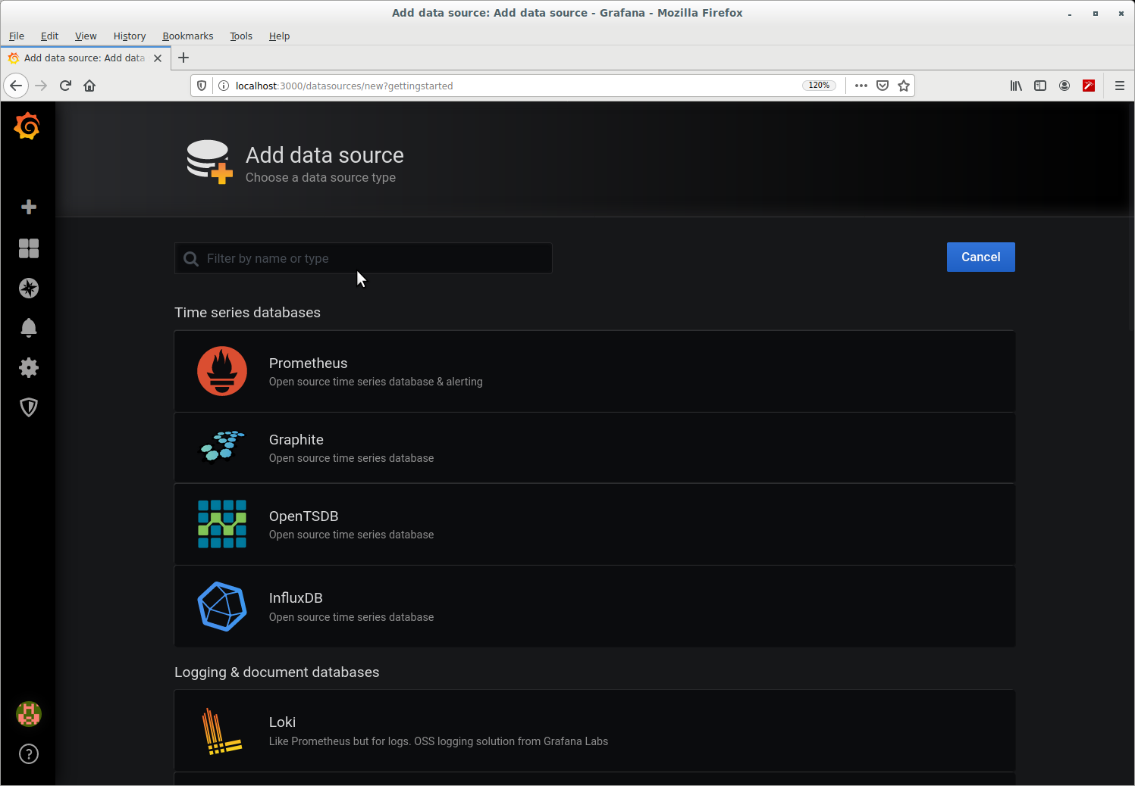

To get:
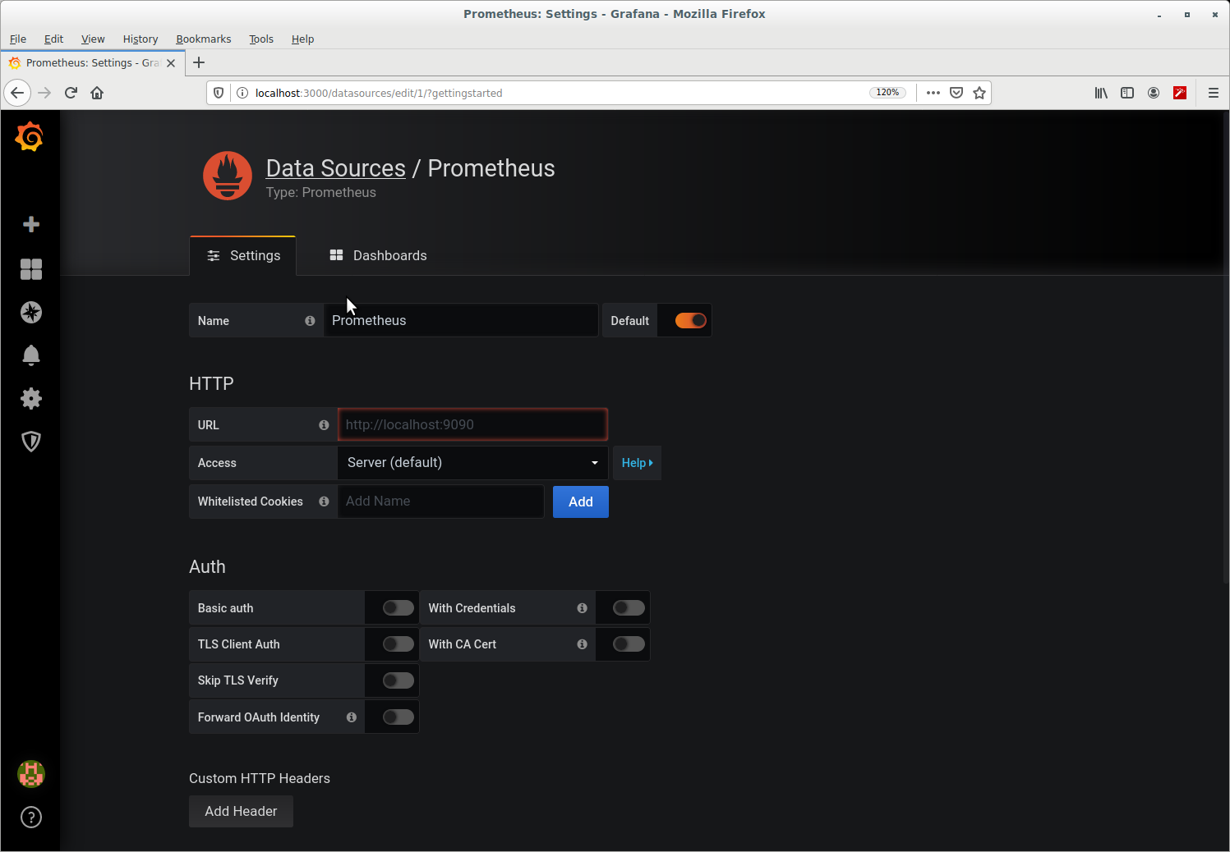
Into the URL text field, enter: http://localhost:9090 and in the Access drop down select Browser.
Then scroll the page up and click Save & Test
Now to create a Simple dashboard, hover the mouse over the ‘+’ near top left and on the pop out under Create, click on Dashboard to get:
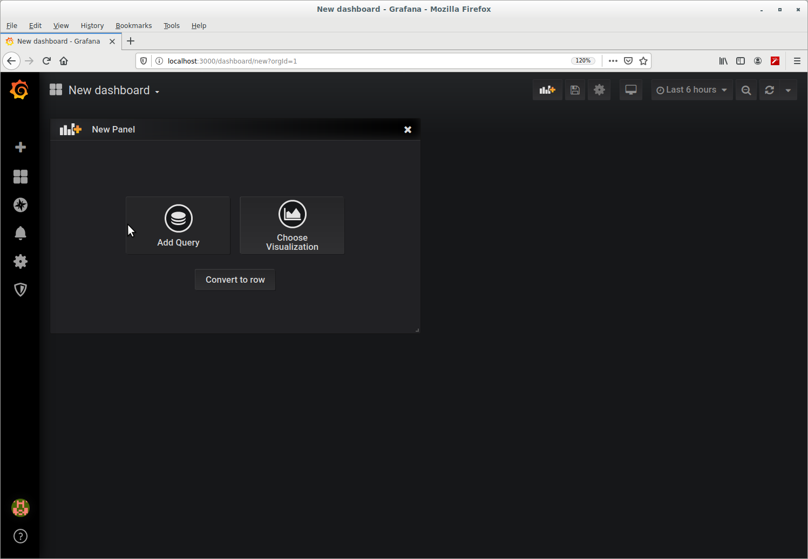
Click on Add Query, and click on metrics to see drop down list and on that list click ‘encrypti...’ and on the list that pops out:
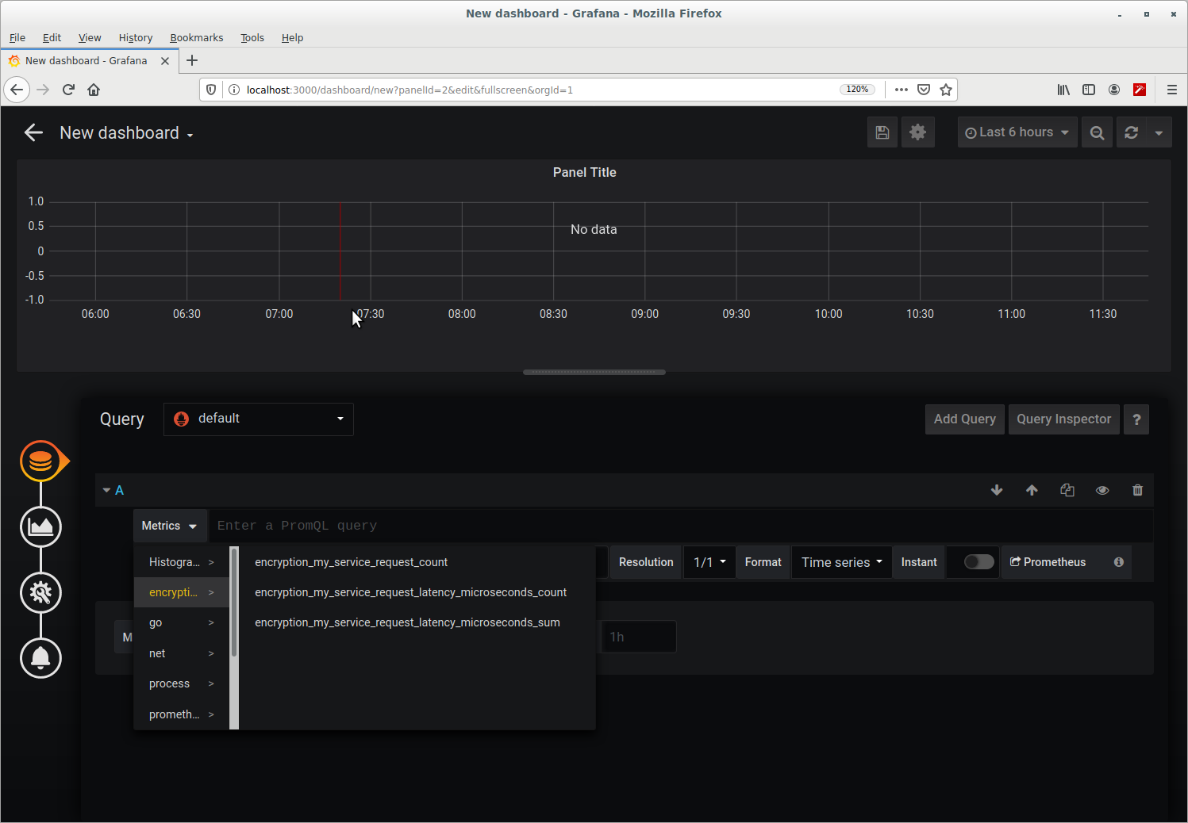
click on ‘encryption_my_service_request_count’ to get:
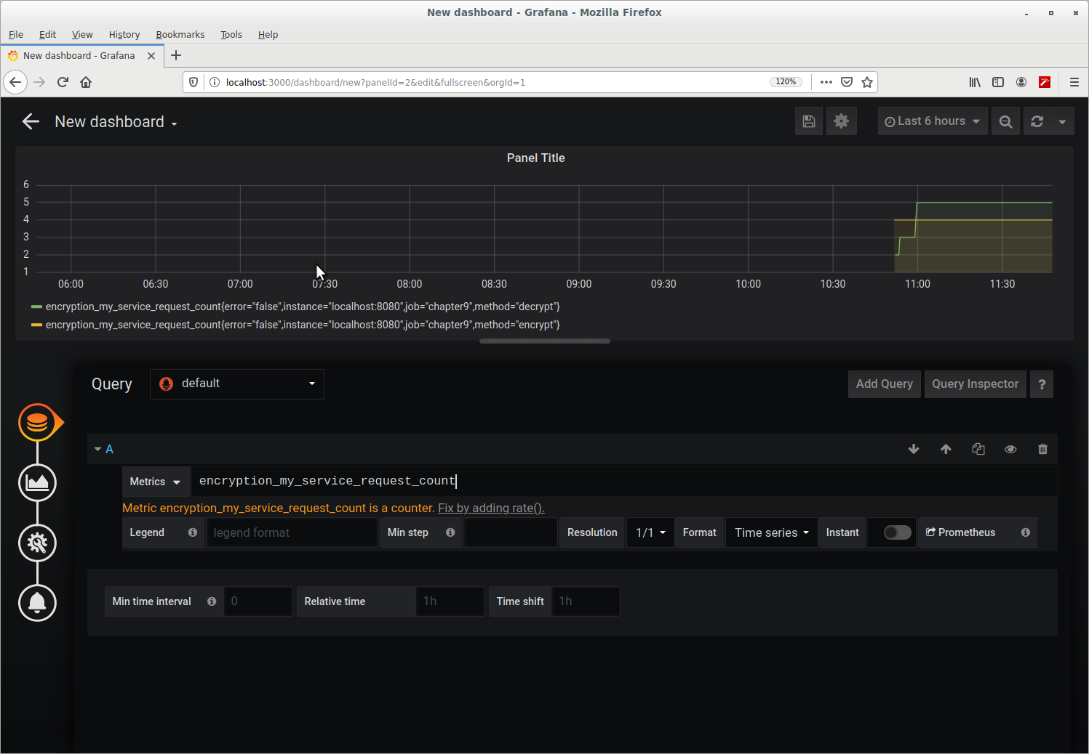

For further information on Grafana, see ...

Grafana, follow instructions on: https://prometheus.io/docs/visualization/grafana/

OR to install into Ubuntu, look for section ‘latest OSS release:’ on this page:
https://grafana.com/docs/grafana/latest/installation/debian/#install-from-apt-repository

See also:
https://www.digitalocean.com/community/tutorials/how-to-add-a-prometheus-dashboard-to-grafana

-=-=-

NOTE: After you have finished with these applications, you may wish to clean up the docker containers … refer back to section ’Useful docker commands:’ for a selection of commands to help yo do this.

